ClearSol: A Self-Cleaning Solar Power System

Fabio Amado, Zachary Capone, Julian Leguizamon, Ryan Rosenberger*,* and Anthony Saab

**Summary**—ClearSol is a self contained solar array in which an Electrodynamic Screen (EDS) is applied over the solar panel. In the case dust accumulates on the panel, the film can be charged, this expelling dust utilizing static electricity. We aim for our design to be fully self-contained, capable of operating in an extreme range of temperatures, and able to power the EDS by itself as well as be able to output a steady supply of electricity to a load.

————————————————

* *Fabio Amado is with the Department of Electrical and Computer Engineering, Boston University, Boston, MA 02215. E-mail:* [*famado@bu.edu*](mailto:famado@bu.edu)
* *Zachary Capone is with the Department of Electrical and Computer Engineering, Boston University, Boston, MA 02215. E-mail:* [*zcapone@bu.edu*](mailto:zcapone@bu.edu)
* *Julian Leguizamon is with the Department of Electrical and Computer Engineering, Boston University, Boston, MA 02215. E-mail:* [*julianle@bu.edu*](mailto:julianle@bu.edu)
* *Ryan Rosenberger is with the Department of Electrical and Computer Engineering, Boston University, Boston, MA 02215. E-mail:* [*rjrose@bu.edu*](mailto:rjrose@bu.edu)
* *Anthony Saab is with the Department of Electrical and Computer Engineering, Boston University, Boston, MA 02215. E-mail:* [*saabanth@bu.edu*](mailto:saabanth@bu.edu)

—————————— ◆ ——————————

## 1 Executive Summary

Missions to outer space require solar energy to power the equipment. There are difficulties associated with maintaining maintenance and upkeep of equipment in space. As space missions can last years there is a need for a frequent, effective, power efficient and water-free system for automatic cleaning is therefore required in order to avoid cutting those missions short.

The final deliverable of our product will be a self-contained, portable, thermally insulated container with the solar panels attached on top with the electrical components held inside the container.

The innovative features in our product are the hybrid combination of the lithium-ion battery with the supercapacitors as our storage component and the monitoring system used as a controller for the EDS film.

Author: Fabio Amado

# 2 Introduction

One of the key weaknesses of photovoltaic (PV) systems is that their efficiency weakens over time if not maintained properly. While maintenance of solar panels can be low cost, it becomes time consuming and less efficient for larger systems such as solar farms and difficult for systems installed in far-off locations such as lunar and mars installations. Depending on the environment solar panels efficiency can decrease up to 25% [1]. There is a need for automated cleaning in solar panels in the space and energy industry. Dust mitigation is a major problem for outer space exploration in locations such as the Moon and Mars. As water is non-existent in these locations, maintaining a clean solar panel is difficult and there is no way to do maintenance on these panels[2]. Solar power systems are a major aspect of NASA’s lunar and mars missions and these systems need to be able to last years.

This weakness carries over to terrestrial solar installations. Since the majority of solar farms are located in arid and desert environments it becomes difficult to do maintenance. These plants encompass large areas of land of around ten to hundreds of acres. The way maintenance is done in these solar farms is by using automated water cleaning systems or manual labor with hoses to wash them down. Currently, industry costs for cleaning a solar farm range from $0.50-$1.00 per module. This would equate to a range of $8000-$16,000 to clean the Goldtree solar farm [3]. Ultimately, this project aims to provide a solution to maintaining a clean and efficient solar power system in both terrestrial and extraterrestrial applications.

When in the field, be it terrestrial or extraterrestrial, solar panels lose efficiency to the dust, dirt, and debris which inevitably blow onto the panel. As a consequence of this buildup, efficiency of the solar panel is continually reduced as more and more surface area is covered by the debris. As a consequence of this issue, large solar farms in places they would be most efficient, such as a desert, become unrealistic as cleaning off the sand is too resource intensive. This is also true for aerospace applications, as sending someone to clean the panels is not an option. In order to solve these issues regarding the situational application of solar panels, Team 29 is presenting ClearSol.

ClearSol is a proof of concept utilizing the application of the EDS in both terrestrial and extraterrestrial environments, and consequently, a self contained set of circuitry in which solar energy is diffused and modified in order to be exported as a steady flow of electrical energy.

Author: Fabio Amado

# 2 Concept Development

The main problem that our system seeks to solve is how to power a load and store energy effectively in a Martian or Lunar environment where temperatures vary between 20C and -63C. In order to achieve those goals we are designing a solar power system equipped with a supercapacitor energy storage system that operates effectively within the environment’s temperature range. Dust mitigation is a major issue with Solar PV systems on the surface of Mars as dust storms are frequent and can negatively affect the power output and thus performance of our system. We are therefore implementing the Electrodynamic Screen in order to deal with the issue of soiling.

Our energy storage system should be able to sustain our load for a period of about 18 hours, assuming 6 full hours of sun on the surface of Mars (1 Sol ≈ 24 hours and 36 minutes). Our load requires 24 Vpp AC voltage, and a 10 Wp of power, but internal components to our system also draw some significant amount of power, which should be accounted for. The PV module produces more than enough power to sustain both the load and internal components when the Sun shines (30 Wp). Our internal system should not draw more than 5W, and so, the remaining energy should be stored in the supercapacitors. The load of our system will not be powered consistently, its duty cycle will dictate when it will operate and draw power.

The way we are going to reach those requirements is through an adequate storage system, charge controller, and power electronics components. A monitoring system would automatically trigger the EDS when enough dust has been deposited on the panel such that it generates 10% less power than predicted. The DC-DC converters will provide adequate power and voltage levels to the EDS power supply and Raspberry Pi. An inverter will be implemented to provide the AC voltage required for our load. The charge controller is equipped with a Maximum Power Point Tracking technology, maximizing the power output of our PV module. It will also be adapted to the supercapacitor’s operation such that it will charge the storage system when required depending on the state of charge of the storage, the amount of power generated by our PV module, and the power drawn from our internal and external loads. An initial design that we had, operated the charge controller as being the central component of our system that had three different outputs, one going to a DC-DC converter, powering our internal DC loads, one going to an inverter, powering the external AC load, and another going to the supercapacitor energy storage system, charging and discharging it depending on the power draws of our loads, and the power generated by our PV module. The MPPT system would be implemented separately from the charge controller and would be directly applied on our panel (i.e using a power optimizer). However, this design is not optimal as there would be more components to buy (for example, the power optimizer would raise our costs significantly), and the converters would not be very efficient as the DC input would be very inconsistent and would vary depending on the weather conditions and illumination from the Sun. The converters switching scheme (i.e. duty cycle of the switches) would have to vary with respect to the varying input voltage levels, and therefore would require more time to stabilize and reach a steady state with each variation, losing efficiency and output voltage stability in the process.

Our current design utilizes the supercapacitors in an ingenious way. Aside from using them as a means to store energy, they could also be used as a low pass filter, minimizing the variations of input voltage to our converters and therefore allowing for a better conversion efficiency. The converters would only have to account for the discharging of the energy storage system, which would require less adjustments than in the previous case. The MPPT charge controller would then be connected directly to the PV module, and would simply be connected to the energy storage system on the output, allowing it to behave like a low pass filter. The converters would then be connected to the output of the energy storage system and operate depending on its output voltage levels.

A problem that we have encountered is the cost of the supercapacitors that would allow us to store the required amount of energy to allow for all of our loads to operate fully over one Mars day (Sol). We decided that we would design a hybrid storage system, consisting of supercapacitors and a Li-ion battery, allowing us to store enough energy.

Author: Anthony Saab

# 3 System Description

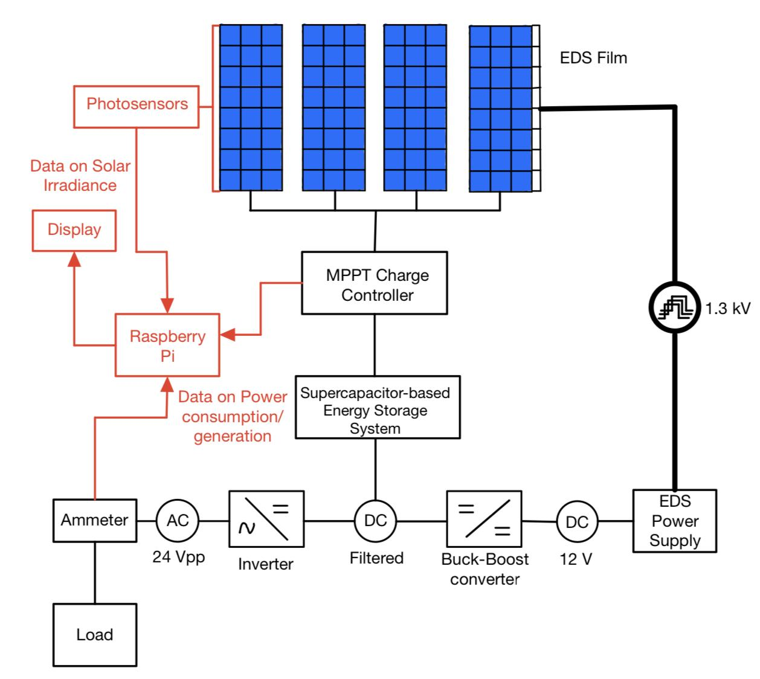

**Figure 3.1.1**: Block diagram of our system

Here we can see the overall block diagram of our system, showing the interactions between all of the components of our system. In red, we represent our monitoring system and data flow between the charge controller, ammeter and photosensors to our Raspberry Pi and display. The DC voltage output from our Supercapacitor-based energy storage system would be filtered, feeding into both a Buck-Boost converter and an inverter, providing appropriate voltage to both the load and the EDS power supply. In this block diagram, the buck converter feeding into the Raspberry Pi is not represented for clarity. The EDS power supply converts the DC 12 V voltage to a three phase squarewave of amplitude 1.3kV feeding into the electrodes of the EDS, effectively sweeping the dust off our PV module’s surface. Some minor changes could be made to this block diagram to facilitate wiring.

Author: Anthony Saab

**3.1 Power Electronics**

Our power electronics components include two DC-DC converters: a buck-boost converter, and a buck converter. The buck-boost converter is used to regulate the filtered DC output of the supercapacitor-based energy storage system to a 12 V DC bus. 12 V are applied to the EDS power supply, that will then output a 5Hz three phase square wave of 1.3kV which will charge the sets of 3 electrodes embedded in the EDS film. This will allow for a dynamic electric field to be created over the surface of the PV module, effectively sweeping out the deposited dust off the surface of the panel. When talking to Professor Mazumder about the operation of the EDS, he estimates that the total process should take about 2 minutes. As the electrodes are almost a purely capacitive load, the EDS screen will not draw too much power, only about 1 W for 2 minutes of operation. Since the EDS will be triggered only when needed, it does not represent a significant power draw compared to the load power requirements of 10 W.

From that 12 V DC bus, we have a buck converter that steps down the 12 V bus voltage to 5 V feeding into our Raspberry Pi 4B microcontroller. Power draws from the Raspberry Pi are significant, as it should be consistently powered. The Raspberry Pi draws about 2.7 W on average, which is significant. An ultra-low power STM32 microcontroller could be used in our final implementation to lower our internal power consumption.

An inverter is also another power electronics component used in our system. It will output a 24 Vpp AC voltage to our load while providing 10 Wp during the load’s operation. As mentioned in the section above, our load will not operate consistently, at least when the Sun is not present, and its operation is dictated by its duty cycle. Our ultimate goal for our project is to be able to operate our load continuously, but this will depend strongly on how effectively we are able to store energy within our budget.

Our MPPT charge controller is another power electronics component used. It uses a Perturb & Observe (P&O) algorithm in order to find the optimal operating voltage and current levels to optimize the power output of our PV module. It also effectively varies voltage and current output to our energy storage system, in order to charge it according to its state of charge. In our system we are currently using a classic MPPT charge controller designed for a lead-acid battery. Optimally, we want to design our own MPPT charge controller to better fit the implementation of supercapacitors, as their power density and energy density differs from classical batteries.

Author: Anthony Saab

**3.2 Monitoring**

This semester we made great progress in the development of our monitoring system and how we were going to design and implement it into our build. Our monitoring system would consist of 3 main elements; the solar panels, a GUVA-S12SD light sensor, and the Raspberry Pi. We will be measuring the output power coming from the solar panels using ammeters and calculate the power the solar panel is producing by feeding that information to the pi. Additionally, we will have our light sensor, a GUVA-S12SD, measuring the solar irradiance of the sun (W/*m2*) and feeding that measurement back to the Raspberry Pi.

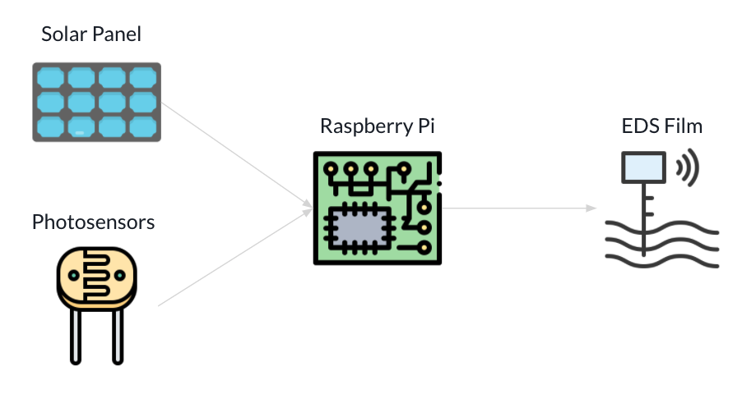

**Figure 3.2**: Overview of our monitoring system

The Raspberry Pi will then take the solar irradiance measurements and determine the power output that should be expected given the current solar irradiance. This will be achieved by creating a function in the Raspberry Pi that takes the solar irradiance as the input and using data that describes the expected solar output for a certain solar irradiance given the specs of the solar panel we will be able to come up with a output that describes the expected power output of the solar panel. Once the Raspberry Pi has this expected value, it will see if it is within the range of the actual measurement coming from the solar panel. Our client mentioned that a good range could be +/-10% of the expected output but we hope to conduct tests in the lab and get perhaps a more accurate tolerance in order to determine when there is dust on the panel. Once the Raspberry Pi determines that the panels are operating at a level that is below the expected efficiency it will make the assumption that there is dust on the panels and activate the EDS films for a period of around 2 minutes. Using this system we hope to be able to drive the EDS without having to tell the system when to activate the EDS. Additionally, during our formal design reviews presentation, some students brought up comments on perhaps other ways that we can determine that there is dust without having to use photosensors. One of the suggestions included measuring the capacitance on the EDS electrodes and seeing if it varies as the amount of dust deposited on the panel increases. This was a very interesting suggestion and we will look into this one and some others in the future in order to perhaps improve our design and come up with new and more creative engineering solutions to this problem.

Author: Julian Leguizamon

**3.3 Mechanical**

The entirety of the system is in itself contained inside of a medium sized beach cooler. This decision was made as beach coolers already inherently possess the insulative and even airtight properties necessary to keep our circuits protected from martian dust as well as portability. The built in wheels and even handle on the cooler allow us to transport the entire unit simply by pulling it around by the handle.

Once the beach cooler was chosen as our base, the cooler was taken to EPIC to have holes drilled through the plastic. These holes were then lined up with a piece of wood placed across the top of the cooler, and screws, in addition to washers, bit through these holes into the wood. This piece of wood would serve as the main ‘rail’ across the lid of the cooler which our solar panel would be mounted off of. All wood used in this project was cut to size.

Once fastened to the cooler, the metal rails that came with the solar panel also had an additional set of holes milled through them. These were used to run screws through a piece of wood between the rails, allowing a point on the panel which would accommodate other hardware being screwed into this component of assembly. Of the two extra pieces of wood attached to the solar panel component of the assembly, one had a larger hinge screwed to it to allow the user to adjust the angle of the entire panel. On the second block of wood, a smaller hinge was attached. This smaller hinge allowed a leg to swing back and forth, giving the user the ability to ensure the cooler stays at a particular angle. As of right now, the panel can be laid flat, at a roughly 45 degree angle, and a 30 degree angle.

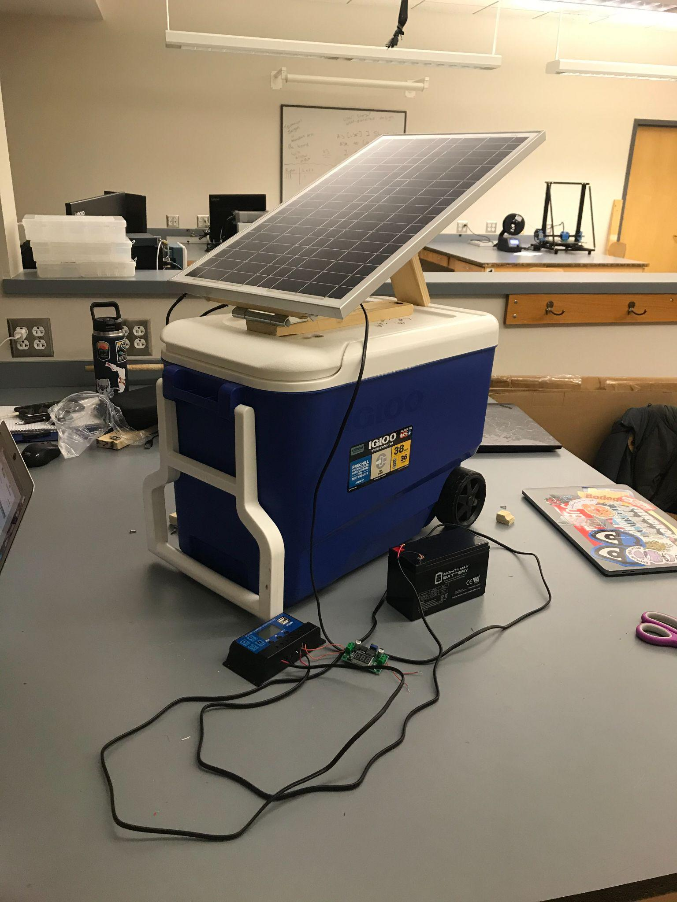

**Figure 3.3.1**: Picture of our mechanical structure

As a result of the ability to hinge our solar panel and insulate our electronics, we will be able to gather a larger range of data in regards to the efficiency of our panel in different weather conditions and different angles/directions within said weather conditions.

Although the final build of the project will have all components and circuitry mounted inside the cooler, we currently have our electronics necessary for the panel outside the assembly. However, the necessary holes to allow the wires in have already been milled and this is just a matter of convenience to work on our circuit for the time being.

Author: Zachary Capone

# 4 First Semester Progress

**4.1 Mechanical**

During the first semester, the entirety of the physical assembly was completed. While a more detailed description of the work done is available above, in terms of progress there is very little if anything left regarding the chassis of our product. Eventually, once the other electrical components arrive and we are ready to place the circuit inside of the cooler, we will likely need to make additional mounts inside of the chassis in order to accommodate all the components. When this time comes however the fixes will likely be very simple, and we have already thought about using plastic paper racks taped or glued to the interior side of the cooler as shelving. Beyond this there is little else that needs to still be completed.

Author: Zachary Capone

**4.2 Monitoring**

Some of the first accomplishments we had during the first semester were gathering the parameters, requirements, and constraints that we would have to take into consideration when designing and selecting the parts to our monitoring system. We were able to come up with early predictions in terms of the amount of capacitance we were going to need in order to power a microcontroller and sensors for a period of around 18 hours. This early success allowed us to select some low power microcontrollers such as the SMT32. However, once it became clear that using only supercapacitors in our system would be beyond the scope of our budget and we made the decision, along with our client, to use lead acid batteries instead we settled on the Raspberry Pi model B+ for our microcontroller. If our budget allows it and internal power draws are too large, we could implement the SMT32 in our final design to improve the system’s performance.

In addition to completing a quantitative analysis of our microcontroller, we were also able to assemble parts of the circuit that would supply the Raspberry Pi with 5V from the solar panel. We assembled the solar panel and connected the output of the PV to a MPPT charge controller that had an output of 12V. Since the Raspberry Pi had an optimal operating range of around 5V we had to make sure it was getting the appropriate amount of power. We connect a buck boost converter to the MPPT charge controller in order to output 5V from the buck boost and successfully power the Raspberry Pi.

Another critical part of our accomplishments this semester was making sure we could automatically power our EDS film without having to manually turn it on. We formulated and designed the system that we are going to implement in order to accomplish this goal. The system that we formulated consists of measuring the output of power coming from the solar panel and the solar irradiance coming from our photosensor and feeding these inputs to the Raspberry Pi. The Raspberry Pi will then determine if the solar panel is performing below expectations given the current solar irradiance and determine to activate the EDS film accordingly.

Author: Julian Leguizamon

**4.3 Power Electronics**

On the power electronics side of our progress, we were able to determine the general layout of our system. This included our major components, and how they interfaced with each other.

We determined that we will have an MPPT solar charge controller connecting our solar panel to our energy storage method. There will be a buck-boost converter connected to that storage producing a 12V DC system bus. To that bus, the EDS power supply, the inverter, and a buck controller will be connected. The inverter will produce a 24V p-p AC output to drive a connected load. The buck controller will produce a 5V DC bus that will drive our measurement and control system (at least initially consisting of a Raspberry Pi).

This system configuration was initially tested using a simulation in MATLAB Simulink. This included models simulating all of the components in our system (with the exception of the load, since it won’t always be connected). The results of this simulation showed that our system configuration made sense and had stable functionality for a prolonged period of time.

We ordered most of the components that will make up this system to build up a physical prototype. These include the charge controller, an initial energy storage method (lead acid battery), a buck-boost converter, and a buck converter. Connecting these elements together, with an attached load to the buck converter, we were able to show that the power flow through the system works as our simulation suggested.

Author: Ryan Rosenberger

# 5 Technical Plan

## 5.1 Power Electronics

There are a few major steps that need to be undertaken to complete the power component of this project.

First, we need to integrate the EDS power supply into the system. This will involve interfacing with our client to get access to the supply, and then connecting it to our system to ensure it can function properly.

Second, we need to integrate the measurement and control components into the system. Our concern here isn’t the functionality of the system with these components connected, rather we need to see what kind of load these components put on the system. This will help decisions moving forward as to updating our energy storage method.

Third, we need to design and integrate the inverter component of our system. This may involve either acquiring and integrating an off the shelf solution if one is available, or designing one ourselves.

Once all of these components have been integrated, our system should be complete and functional. At this point, we will work on improving various aspects of the system. Chief among these is the energy storage component. Our current solution is a lead acid battery, while our client would like us to incorporate supercapacitor storage. We would also like to explore lithium ion storage options. Once we have a better understanding of the realistic power requirements of the system, we will be able to select a storage option that will work in our system within our budget. Once we have this understanding, we will design and implement the updated storage solution.

Finally, we would ideally like to integrate the power components of our system onto one board, along with our systems for measurement and control. This would potentially come along with designing power converters for improved efficiency. This, however, is not strictly necessary for the completion of our project. For this reason, this is a stretch goal that will only be pursued if we have the system working properly with time to spare.

Author: Ryan Rosenberger

## 5.2 Monitoring

The technical plan for the future of the monitoring system is to work on implementing and debugging the code for the Raspberry Pi to take the two inputs from the solar panels and photosensors and calculate the power output from the solar panels. If the Raspberry Pi calculates that the power from the panels is lower than what is expected from the sensor data it would activate the EDS.

*Task 1. Implement the Monitor System*

Connect the Raspberry Pi to the photosensors and solar panels. Make sure that the assembled PV array is connected to a MPPT charge controller that has an output of 12V. Since the Raspberry Pi has an optimal operating range of around 5V we have to make sure it is getting the appropriate amount of power. Test the buck boost converter to the MPPT charge controller in order to make sure the output 5V from the buck boost successfully powers the Raspberry Pi. Attach the photosensors to the Raspberry Pi.

*Task 2. Testing the Photosensors*

Test the photosensors and make sure that they correctly gather the data. Check the solar irradiance received from the photosensors and compare with the power output from the assembled PV array. Make sure that the sensors are matching with the PV array and then test with different irradiances.

*Task 3. Work on Implementing the Program for the Monitoring System*

Work on implementing a python program for managing the monitoring system. The program needs to be able to read the data from two different inputs of the solar panels and photosensors. It takes these data and calculates the power output from the solar panels and checks if it is performing below expectations given the solar irradiance. The Raspberry Pi should be able to activate the EDS film for a period of 2 minutes if the solar panel output is below expectation. The monitoring system also needs to display the data on a monitor screen like an LCD.

*Task 4. Incorporate system into the physical assembly*

After the entirety of the system is functional, we will stress test it to ensure that everything is working properly, and at this point insert it into the cooler. We will likely need to drill an additional hole into the side of the cooler for the lcd display screen to be able to poke through, however this may not be necessary if it is communicating with a remote operating system. If desired we would likely just stick to monitoring and controlling the system remotely with the software which we will eventually program.

Authors: Fabio Amado and Zachary Capone

# 6 Budget Estimate

Our budget includes components already purchased and possible components to implement. We have already purchased a buck converter to the Raspberry Pi, a buck boost converter going to the EDS power supply, an MPPT charge controller, wood and hinges for the panel mount, a cooler as a physical chassis, cables and a lead-acid battery. The PV module, EDS and EDS power supply have been provided by the client. We also have a Raspberry Pi for our monitoring system. We are yet to purchase supercapacitors, an inverter, a Li-ion battery, an LCD display, photosensors, and possibly an STM32 microcontroller. The main budget constraints are with respect to the supercapacitors. Indeed, according to a rough calculation, we would need about 90kF of capacitance to store enough energy for our load to be powered for 18 Sun-less hours. This will cost us about $864 according to the cheapest source we could find, consisting of 3 modules of 4 9000F supercapacitor pouches that cost $72 per supercapacitor. To fit our maximum budget of $750, we will need to purchase a Li-ion battery to store most of our energy required to power our loads. We will be purchasing one of those modules of 4 pouches for our final design. The inverter is yet to be designed, and therefore the costs of its design are just estimated. We intend to possibly purchase an STM32 microcontroller if our internal power draws are too large. For our physical assembly, our final cost came out to be exactly $55 and no change. The most expensive item was the beach cooler, which cost $33.99 from the Target in fenway. The rest of the expense came from purchasing the wood used as well as the two hinges. All other hardware and tools, including the saw the wood was cut with, the screwgun, and even the screws and washers themselves were taken from the laboratory.

| Item description | Cost ($) | % of $750 |
| --- | --- | --- |
| Panels 30Wp (Voc 22.9V, Vmp 19.5V) | 0 | 0% |
| Cables | 14.99 | 2% |
| Wood | 9.99 | 1.332% |
| Hinges | 9.78 | 1.304% |
| Cooler | 33.9 | 5% |
| Charge controller | 0 | 0% |
| Supercapacitors | 288 | 38.4% |
| Buck converter | 9.99 | 1.222% |
| Buck-Boost converter | 15.99 | 2.132% |
| Inverter(estimate) | 25 | 3.33% |
| EDS power supply | 0 | 0% |
| Lead-Acid Battery | 17.5 | 2.33% |
| Photosensors | 12.14 | 1.619% |
| LCD display | 21.32 | 2.843% |
| Li-ion Battery | 84.99 | 11.332% |
| STM32 Microcontroller (optional) | 40 | 6.854% |
| **TOTAL** | 583.60 | 79.334% |

Authors: Zachary Capone & Anthony Saab

# 7 Attachments

## 7.1 Engineering Requirements

The following are the engineering requirements of our system. The table is split into 3 main sections, power electronics, mechanical, and monitoring. It describes the main engineering requirements for each of the subsections of our project and breaks them down into the specific parameters of each requirement.

| **Power Electronics** | **Requirements** |
| --- | --- |
| System Voltage | A DC-DC converter will be used to provide a constant 12V DC system voltage |
| Output Power | 24V p-p AC output, at a peak power of 10W |
| **Mechanical** | **Requirements** |
| Enclosure | The system must have all components except the solar panels enclosed |
| Temperature | Withstand temperatures in the range of 20℃ to -63℃ |
| **Monitoring** | **Requirements** |
| EDS Film | Raspberry Pi will automatically activate EDS films |
| Measurements | Raspberry Pi will be able to compute internal voltages and currents of the system. |

**Table 7.1.1**: Table describes the different parameters for our project

Author: Julian Leguizamon

## 7.2 Gantt Chart

Screenshots of our current GANTT chart are provided below.



**Figure 7.2.1**: GANTT chart for the first 8 weeks of the ClearSol project (September 27th, 2021 to November 21st, 2021)

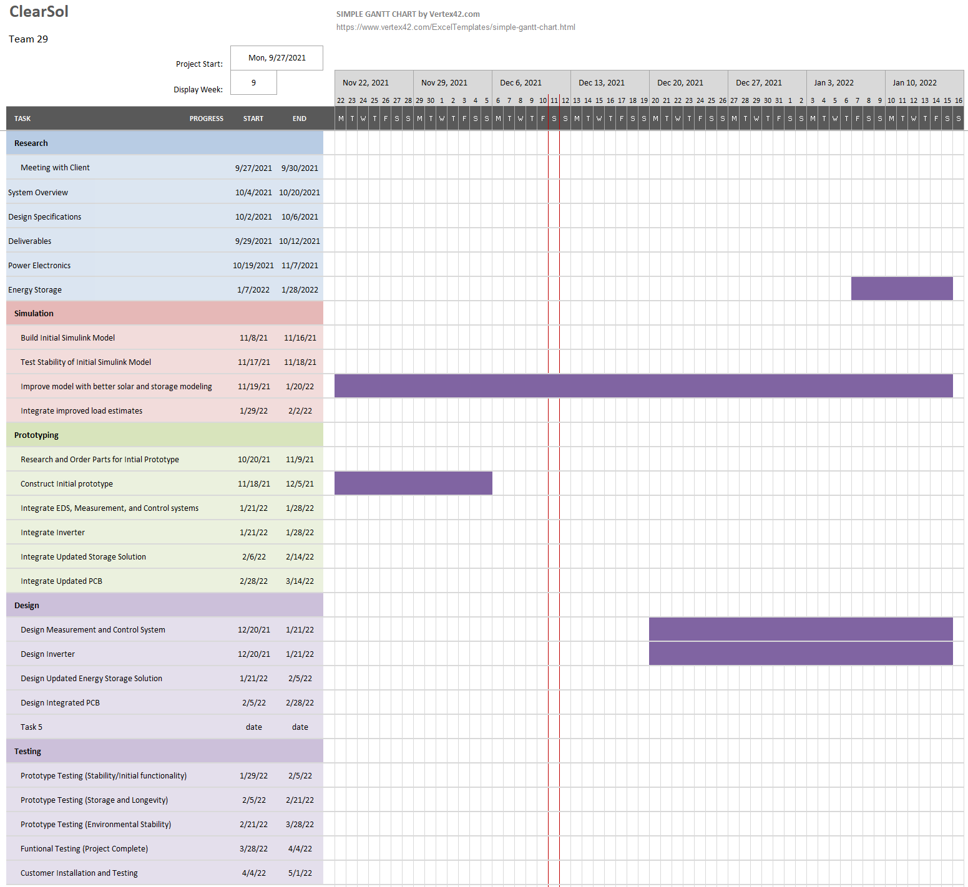

**Figure 7.2.2**: GANTT chart for the second 8 weeks of the ClearSol project (November 22nd, 2021 to January 16th, 2022)



**Figure 7.2.3**: GANTT chart for the third 8 weeks of the ClearSol project (January 17th, 2022 to March 13th, 2022)

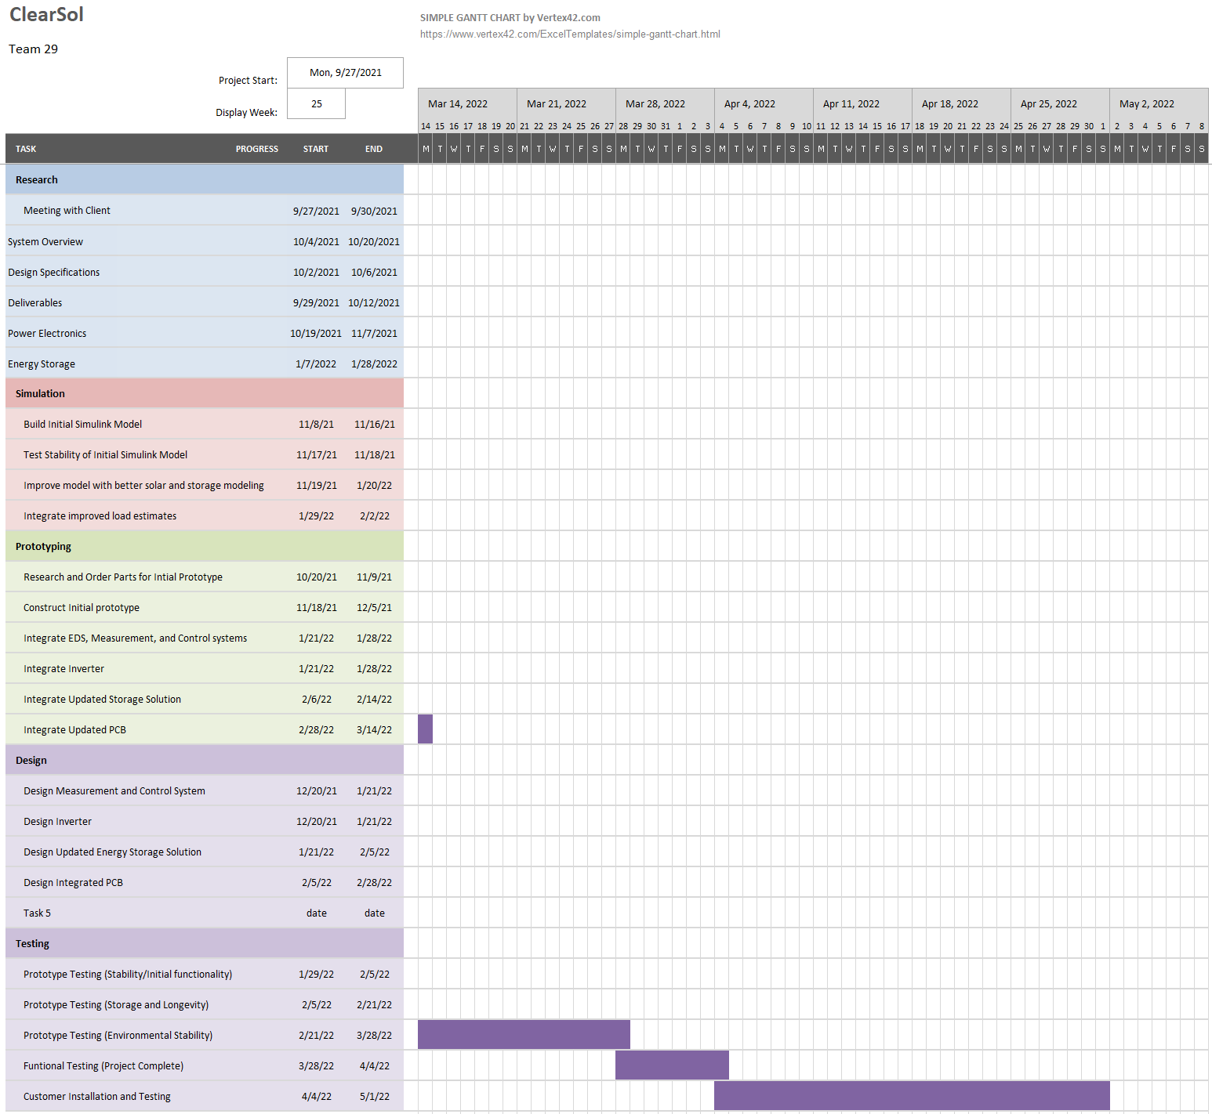

**Figure 7.2.4**: GANTT chart for the fourth 8 weeks of the ClearSol project (March 14th, 2022 to May 8th, 2022)

Author: Ryan Rosenberger

## 7.3 Other Appendices

**Acknowledgment**

The authors wish to thank Professor Malay Mazumder for continued support throughout the project.

**References**

1. A. Thompson, “Pollution could block 25 percent of the light that would become solar power,” Popular Mechanics, 15-Feb-2018. [Online]. Available: [Solar Panel Efficiency Dramatically Reduced by Dirt and Pollution](https://www.popularmechanics.com/science/energy/news/a27112/pollution-can-block-25-percent-of-solar-power/#:~:text=They%20found%20that%20solar%20panels,of%2035%20percent%20or%20more). [Accessed: 22-Oct-2021].
2. Malay K. Mazumder, Life Fellow, IEEE, Mark N. Horenstein, Life Fellow, IEEE, Nitin R. Joglekar, Member, IEEE, Arash Sayyah, Jeremy W. Stark, Annie A. R. Bernard, Sean M. Garner, Julius E. Yellowhair, Hung Yi Lin, Ryan S. Eriksen, Alecia C. Griffin, Yujie Gao, Ricci La Centra, and Alexis H. Lloyd, “Mitigation of Dust Impact on Solar Collectors by Water-Free Cleaning with Transparent Electrodynamic Films: Progress and Challenges” IEEE Journal of Photovoltaics, Vol. 7, No. 5, September 2017.
3. Stockburger, S., &amp; Rios, V. J. (2020). Energy and Economic Losses due to Soiling on Utility Scale PV Systems to Guide Timing of Cost Effective Cleaning. Digital Commons @ Cal Poly. Retrieved October 22, 2021, from <https://digitalcommons.calpoly.edu/cgi/viewcontent.cgi?article=1530&amp;context=eesp#:~:text=Currently%2C%20industry%20costs%20for%20cleaning,and%20decrease%20the%20profit%20margin>.